**Objective:**

**Create a dashboard to compare all the parameters mentioned above for different countries, to strategize market penetration and to target new customers.**

**Datasets:**

Primary Dataset – Insurance Sample Dataset

Secondary Dataset – Global Financial Development Database

**Calculated Fields:**

**Calculation1:**

CASE [Category]

WHEN 'LS' THEN [Life insurance share]

WHEN 'MS' THEN [Market share > Total]

WHEN 'Pen' THEN [Penetration > Total]

WHEN 'ROR' THEN [Ratio of reinsurance accepted > Total]

WHEN 'RR' THEN [Retention ratio > Total]

END

**Current Year :**

IF [Year]=DATETRUNC('year',[Year Parameter])

THEN

[Calculation1]

END

**Previous Year:**

IF [Year]=DATEADD('year',-1,DATETRUNC('year',[Year Parameter]))

THEN

[Calculation1]

END

**Growth %:**

[Previous Year %]-[Current Year%]

**Public Account Link**

<https://public.tableau.com/shared/42KXR9ZGF?:display_count=n&:origin=viz_share_link>

**Screen Shot of Dash Board**

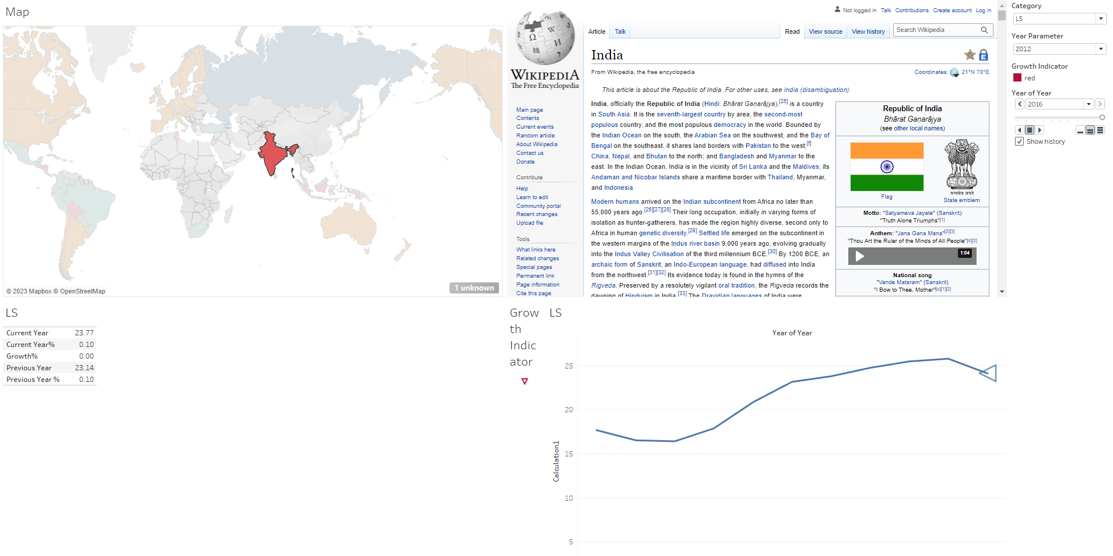

**Screen Shot of Tableau**

